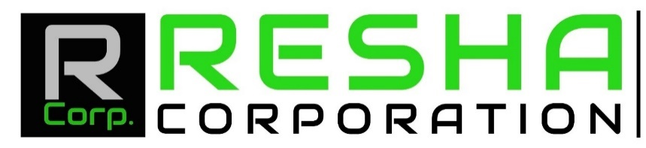

Top 50 Projects Portfolio

1: University of Houston Indoor Football Facility (Houston)
2: AT&T Center (San Antonio)
3: National Tube Supply (Baytown)
4: Dicks Sporting Goods (Sugarland)
5: Ulta Cosmetics (Houston)
6: Davita Dialysis Clinic (Cleveland)
7: Memorial Herman (Katy)
8: Stripes (Cleveland)
9: Mccoys Lumber (Dayton)
10: Hardin Independent Middle School (Hardin)
11: Aldine Isd Elementary, Ms, Hs (Aldine)
12: Valvoline (League City)
13: Boccard Pipe (Houston)
14: Cmc (Houston) & (Midland)
15: CRG (Mont Belvieu)
16: Ineos (La Porte)
17: Shell (Deer Park)
18: Chase Bank (Kingwood)
19: Clutch bar (Houston)
20: Concrete Cowboy (Houston)
21: Handle Bar (Houston)
22: Town House Development (River Oaks)
23: Galleria (Houston)
24: Bob Moore (Roundrock)
25: Audi Dealership (Katy)
26: Tri Color (Houston)
27: Louis Vuitton (Woodlands)
28: Bombshells (Cypress)
29: Park lane Apartments (Katy)
30: Kirby Retail Center (Houston)
31: Made Ya Smile (Houston)
32: Outback Steakhouse (Baybrook)
33: Valvoline (North Fwy)
34: Katy Retail Center (Katy)
35: Jason Deli (Baytown)
36: Sienna Plantation (Katy)
37: Tractor Supply (Montgomery)
38: Phillips 66 (Sweeney)
39: Akzo Nobel (La Porte)
40: Hwy 99 Mow Strip (290)
41: Safe Chemical (Baytown)
42: Roadhouse (Beltway 8)
43: NS Industrial Park (Beltway 8)
44: Aldi (Houston)
45: Deerwood Industrial Park (Deerpark)
46: Walmart (Eagle Springs)
47: CVS (Pearland)
48: Starbucks (River Oaks)
49: Hooks Airport Repair (Spring)
50: Ellington Field Airport Repair (Ellington)

